**DISCUSSION MANAGEMENT**

**EXCHANGING OPINIONS**

*Task 1. Have you ever had a major disagreement with someone at work? What did you do in that situation?*

*Do you agree that ‘The customer is always’ right? Why / why not?*

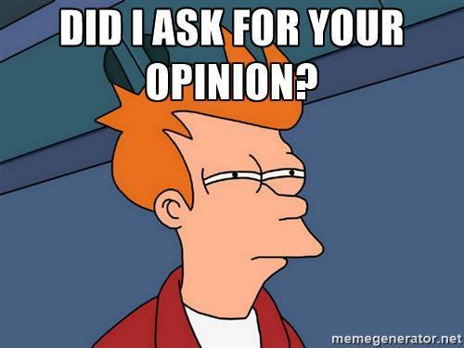

*Task 2.*

1. *Watch* [Video 1](https://youtu.be/MygA4BV8YZM?t=1718) *and answer the question: What does the speaker ask Reto’s opinion on?*

*_______________________________________________________________________*

*Now watch the video again and fill in the gaps:*

It’s about de-bouncing the back button. For example, if you’re heading Back multiple times and quickly try to escape an app, which most users tend to do, it'll take you back a lot further than you intended to. So __________________ giving some feedback to users when they're hitting Back in a short amount of time?  
RETO MEIER: So I think I'm going to answer that question by answering a slightly different question.

1. *Watch* [Video 2](https://youtu.be/k1_8N-KToPs?t=2812) *and answer the question: What does the speaker ask Reto’s opinion on?*

*_______________________________________________________________________*

*Now watch the video again and fill in the gaps:*

Now, you had a look at FastBooking. >> MEIER: Yeah.

>> NI-LEWIS: And I think we already looked at several of the features of this app but

________________________ the UI? >> MEIER: So again, this UI looks really kind

of--it's kind of interesting because it's--it is flat which is nice. We kind of like this--the

flat idea in Android but again it feels like it's a little bit too cramped.

1. *Watch* [Video 3](https://youtu.be/Bncz9inVJzY?t=533) *and say if the statement is true or false: Experiencing things is cooler than making them.*

*_______________________________________________________________________*

-a little quote here from the article. It says, “By letting us into his crafting world, Savage has exposed us to an idea that’s been long lost in popular culture: experiencing things is cool, making them is way cooler.” Right._______________, and frankly anyone who has been creating for a while, be it a woodworker, a sculptor, a metal worker, these people know this already.

1. *Watch* [Video 4](https://youtu.be/Odw2hY88Qmk) *and answer the question: What would be too much to ask according to Reto?*

*_______________________________________________________________________*

*Now watch the video again and fill in the gaps:*

RETO MEIER: What are the things it really need in order to be a good app?

IAN NI-LEWIS: Well obviously, it needs to tell me today’s weather, right?

RETO MEIER: That seems like a pretty good start.

IAN NI-LEWIS: Because obviously, I don't want to get out of bed or open the window.  
RETO MEIER: _____________________. That would be too much to ask, right?  
IAN NI-LEWIS: _______________________.

1. *Watch* [Video 5](https://youtu.be/6Nb65wOWoT8) *and answer the question: What are the main features of a great app according to the speaker?*

*_______________________________________________________________________*

*Now watch the video again and fill in the gaps:*

Paul, Renato, do you guys have anything that you’ll look for in a really great web app? That's what I personally would be looking for.

PAUL LEWIS: No, for me I thing you hit the nail on the head. It’s gotta be something that people love using. And I think a well-built app, well executed that fills a real user need. That’s what I personally would be looking for.   
RENATO MANGINI: Yeah___________________. I second that. It's a perfect answer.  
PETE LEPAGE: Cool.

*Task 3. The following phrases can be used to state one's opinion or disagree. Fill in the gaps to complete the phrases:*

* _s I s_ _ it...
* I w_ _ ld d_ _ _ _ _ee...
* I t_ _ _ your p_ _ _t but...

*Task 4. Sort the expressions in the table below:*

|  |  |
| --- | --- |
| Asking for an opinion |  |
| Stating your opinion |  |
| Agreeing |  |
| Disagreeing |  |
| Referring to somebody’s thoughts | As ... (has) pointed out...  As ... (has) mentioned... |

*Task 5. Work with a partner. Play noughts and crosses, complete the phrases:*

|  |  |  |
| --- | --- | --- |
| How ____ you feel ______ that? (asking for an opinion) | P___________ly. (agreeing) | As Mike p_________ _____ previously,... ( referring to smb’s thoughts) |
| We  ____________  agree more. (agreeing) | Actually, I _____d  disagree entirely (disagreeing) | A___________ly (agreeing) |
| I ________ your point but… (disagreeing) | What _____ your  thoughts ____   this? | ____ I see it, any game I win was designed perfectly |

|  |  |  |
| --- | --- | --- |
| E________ .(agreeing) | As Tim _____ just m__________,.. (referring to smb’s thoughts) | How ____ you _______ ______ that? (asking for an opinion) |
| I ________ your p______ but… (disagreeing) | P___________. (agreeing) | What are your  _______ __ this? |
| ____ I ______ it, any game I win was designed perfectly. | Actually, I _____d  d_________ entirely (disagreeing) | We  couldn’t  __________   _______. (agreeing) |

*Task 6. Work with a partner. Pick a word, say it to your partner – he or she should say the whole phrase containing this word:*

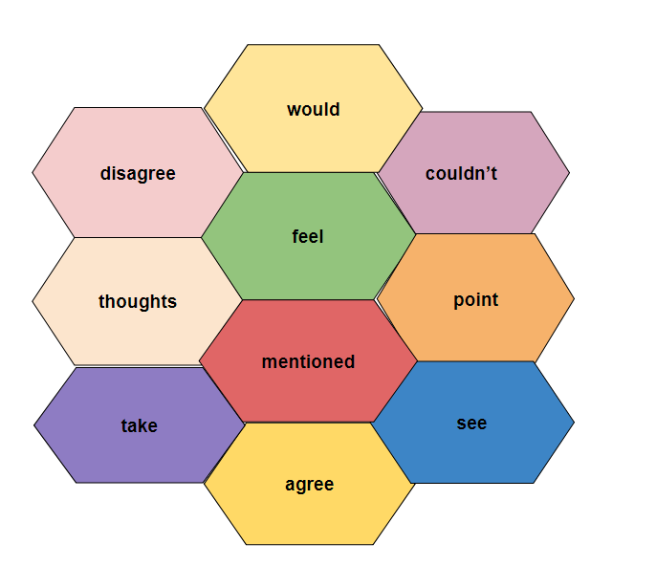

*Task 7. Pick a statement, agree or disagree using the key phrases and give your reasons.*

1. Working from home is better than working at the office.
2. You should always take the initiative.
3. A company should provide training courses only to the best employees.
4. If you’re a manager, you should be the first to arrive at work and the last to leave work.
5. It’s important to get on well with your teammates.
6. Some people say it’s good to change jobs frequently.

*Task 8. Work with a partner. Discuss the following situation.*

“Your teammate Alex has left the company. There have emerged some unexpected issues connected with the tasks he was working on.”

**Student A**, share your opinion on the problem with your partner. Ask him for his/her opinion.

**Student B**, disagree with Student A. Give reasons.

**Student A**, agree / disagree with Student B.

**Student B**, agree / disagree with Student A.

*Now swap roles and talk to a new partner.*

*Task 9. Role-play the dialogue using the key expressions.*

‘A recently requested feature conflicts with the previous requirements. With this new feature, the app will work too slowly. Its implementation is critical and the release should be postponed. However, the customer refuses to extend the deadline.’

**Student A**, start the meeting. Talk about the problem. Ask Student B for his/her opinion on the point.

**Student B**, state your opinion.

**Student A**, disagree with Student B. Nominate Student C to express his/her point of view.

**Student С**, refer to Student B’s thoughts, disagree.

**Student D**, disagree with Student C. Refer to Student B’s thoughts, agree with him/her.

**Student A**, settle the argument, summarize. Finish the meeting.